Thursday Renju Class in 5lin.

- 教育訓練組 對 ○助教
Opening i11.

Mar 16 23:13
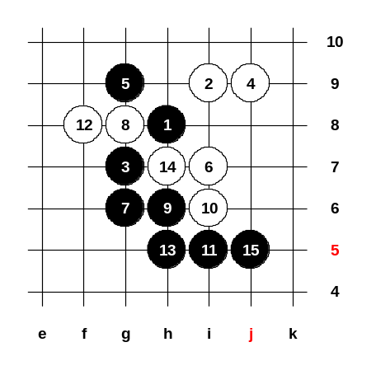
Today we begin with new opening, i11. This opening has black advantage, however, white has good chances to fight in this opening. There are some choices for the 4th move. But all 4th moves except h9 will lose for sure. Lets take a look at those losing 4th moves first. The 4-j9. Haha, yes yes, this is CICI style. This 4th move is very interesting. ^^ Who is CICI? CICI is a beautiful and strong renju player from Taipei. OK, how about the 5th moves here? Anyone knows? Finite555 says g8 and h9, but both moves give white win. The 5-i7 is lost move too. If 5-i7 then 6-g9, 7-h9, 8-h7, 9-i8, 10-j8. Yes, 5-g9 is one of the right moves. True, h6 is another right move! Lets study g9 first. The 6-i7. What is your guess for black next move? Somebody says g6, any other ideas? Somebody says f8, but after 7-f8 white can win directly. The 7-g6 is correct. Those who were in the class when we studied i12 opening, they should remember this position. We studied it from the sequence h8, i9, g6, j9, g9, i7, g7. So, if you check the old files of renju class, you will find it. We can just repeat the first 15 moves here and close the diagram. Ok, homework now.

Mar 16 23:10
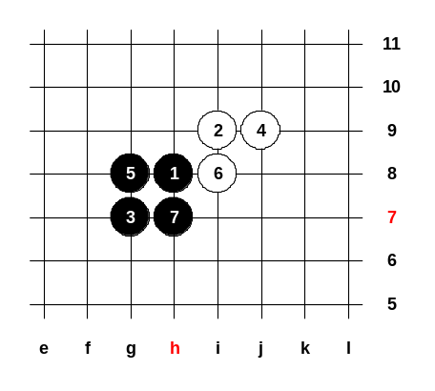
Homework is easy today. You have to show the white win after mistaken 5th move (5-g8). Please find the white win after the 7th move.
See you all next week! Have a happy weekend!

peter_w : Mar 18 11:25
8-h9, 9-g9, 10-g10, 11-j7, 12-k9, 13-L9, 14-i7 white win.

萬盤棋 : Mar 19 21:53
8-h9, 9-g9, 10-g10, 11-j7, 12-k9, 13-L9, 14-i7 black 3x3.

教育訓練組 : Mar 23 21:20
Correct answers, thank you ^__^

Mar 23 23:06
Welcome to renju class! ^__^
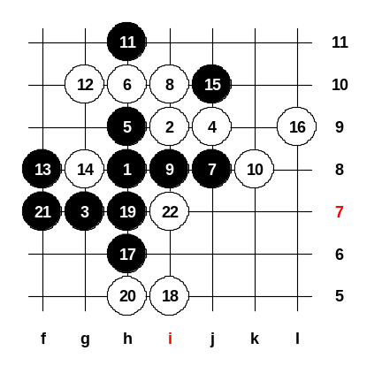
We are studying i11 opening, we continue learning the 4th move to j9. I told you last week that the right 5th moves here are g9 and h6. But, some days ago, hne had a question about 5-h9. Even though black already has two winning 5th moves, some people are curious about 5-h9. People want to know if it is good for black or white. I think it is good for white, although no books say anything about it. Maybe I am right, maybe wrong, we can together find out. There are two possible continuations, 6-j8 or 6-h10. At the moment, 6-h10 seems stronger move. How about the 8th move? Yes, i10, good! ^_^ Where is the best 12th? Yes, 12-g10 is the only way. If 13-j10 then 14-f8 and white continues play in positional style. The problem becomes when black plays 13-f8 first. Positional style = play around the board, trying to control or fight about the control all over the board. The other style is "straight style" - straight development and attack usually in one area only. So, please remember the "positional style" and "straight style". Here, after 15th move was a big question, how to play next white move. Hne asked me the best white way some days ago because he had failed as white when he put 16-h6 (because of 17-f10). So, finally I did some analysis about the move 16-L9 (I posted this idea to the hne's game discussion, too). The 16-L9 is powerful, but the only worry is the possible black attack. The 17-h6, 18-i5, 19-h7, 21-f7. This is the way black can attack here, but after 22-i7 black attack is dead because white will have VCF threat. This is not 100% sure analysis, it is just an idea. Anyone who wants, can study this more deeply at home. If you find some errors in my analysis, you can tell about it next time and we can take a look at it. Anyway, we will not spend too much time on that 5th move because we already have two winning 5th moves. We will close this board now and continue learning the other winning 5th move.

Mar 23 23:03
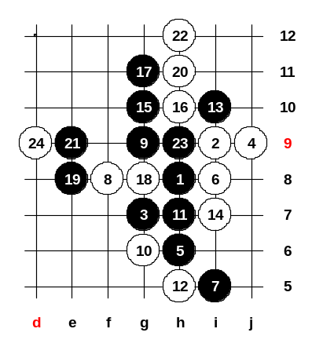
Last Thursday I told about winning 5-g9, so now we look 5-h6, also win. What is the best white move? Right, 6-i8 is the best. How about the black move? I tell you one hint: black has only one choice, any other choice will lose. fivestar thinks f8, any other ideas? If 7-g6 then 8-h9, 9-g9, 10-g10 and i7 point will become 3x3. If 7-g9 then 8-i7 and g6 point will be 3x3. If 7-f8, 8-i5, 9-g6, then 10-i6 and g9 point will be 3x3. The right way is 7-i5 and 9-g9. Now white has two choices, 10-g6 or 10-i7, but actually the both lead into same variant. Lets try 10-g6. It is not easy to find the 13th move here. Black's any attack can begin with using one of the threes. After using any black three, white will play a white three at i7. Black must block white's three from i10. So, if black must play i10 in next move anyway, it is the most wise to play i10 immediately and not use any black three yet. So, remember the rule: black has 3x3, white has a line to threat that 3x3, so black best move is to block white line and not to touch any black 3. If you do so, then white is usually forced to play the next white stone into 3x3 point as it is the best defense move. Look now: if black stone is in i10 and white is in i7, that means, in the next move black has much more choices to play anywhere he wants. Now, after 14th move, we get the same position as it would come from the sequence 10-i7 and 12-g6. Black has many good moves now, but only one of them is good enough to give winning attack power. Who knows that 15th move? Wow! I agree, 15-g10 is the best! Even though 19-e11 or 19-f10 seem strong, white can disturb black attack at e8 or f7 point. The analysis has proved 19-e8 to be the black sure win. The 19-e8 is the attack and the defense at the same time. Now, I will show you one of my home analysis from 9 years ago. Oh, but time is 11pm now, We cannot finish my analysis now. Maybe it is even good, because now you can study it as a homework. Please find the black win here and if you find it, please post it to the board discussion. Next Thursday we will discuss your homework answers and I will show you my analysis from 9 years ago. I just tell you, the win is not very easy. ^_* Who finds the win from move 25 here, he made a very good study. Thank you all, and see you next Thursday! ^__^ 再見!

奕學 : Mar 29 16:44
25-11, 26-10 (or Black vcf. t10,e10,d10,g13) 27-f11 ! Black has 4 swords on top board.
If 28-g12; 29-f13 is double threat.
If 28-e12; 29-f12 is double threat.
If 28-d12: 29-d11, 31-e12,33-f13,35-f12 win !
If 28-d12, I can't win.

萬盤棋 : Mar 30 19:50
It is too hard for me to find the answer!and the first move is very important!!I think black need to creat a good situation to play here! and then win! but it is not very clear to find the move!So I have a headache! and need the medience ( GOOD ANSWER) to cure it!:(

奕學 : Mar 30 21:18
sorry, 25-e11:26-e10.

Mar 30 22:34
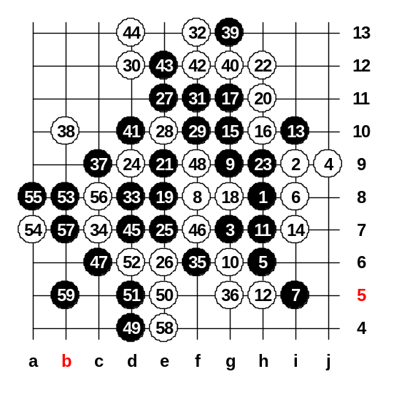
We will look at last week homework. Did anyone of you find the win? Somebody says 25-e11 and 27-f11. If black plays 25-e11 and 27-f11 then white plays 28-d11, where is black next move? Somebody says, 25-e7, 26-e6, 27-e11, 29-f10, 31-f11. Let's look. Let's think of the next white move. Yes, f12 is one of the best white moves, I agree. But assistant showed the win here, so lets try 32-f13. Our assistant found very good way for attack ^__^ Please everyone help the assistant to search the win. Very good! ^_^ How about 36-c9?

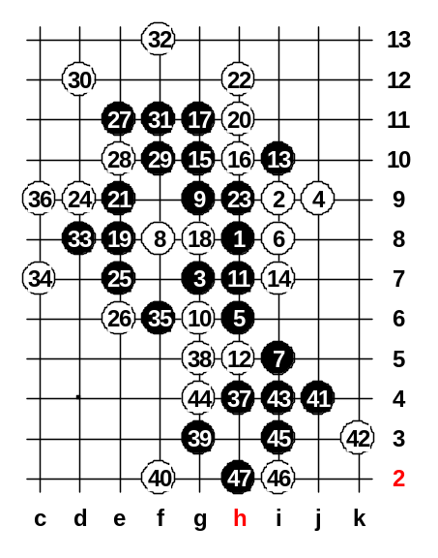
Mar 30 23:19
Assistant found very beautiful win, congratulations to him ^__^
Now, 36-c9. If 46-i1 then black VCF - i6, j6, L6. Well, it seems black wins. Do you agree? What is our assistant name? we can publish his name and tell he found a win.
(哈哈哈哈哈) Please close this board and open new, I give homework ^^

Mar 30 23:17
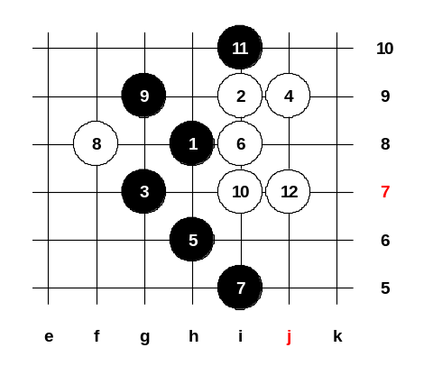
We play 10-i7 this time. Homework question: Please find the black win after 12-j7. This time the homework is much easier! I wish you happy week and successful study! ^_^

素早!? : Mar 31 17:47
13-H5 Black Win

奕學 : Apr 1 16:00
Yes 13-h5 is win. But white has 3 stops.
A.14-h4 (bad move):15-j5-〉vcf
B.14-h7, 15-g6
1. 16-g10, 17-h9, 18-g5, 19-i6, 20-f6 (must), 21-i4, 22-f7 (f7 is 43 of black) Black vcf at bottom.
2. 16-g5, 17-f7, 19-g8 (43)
3. 16-g8 (middle), 17-j5, 18-any, 19-j3 win.
C.14-h9, 15-g10
1. 16-g11, 17-j5 -> g8, h7 win
2. 16-g6, 17-h7, 19-j5 ->g8 win.
3.16-g8 (middle), 17-j5. If 18-g5,19-k6 win. If 18-k5,19-j2 win.

教育訓練組 : Apr 6 21:24
Perfect Answer! ^__^ Very correctly performed, too! Congratulations!
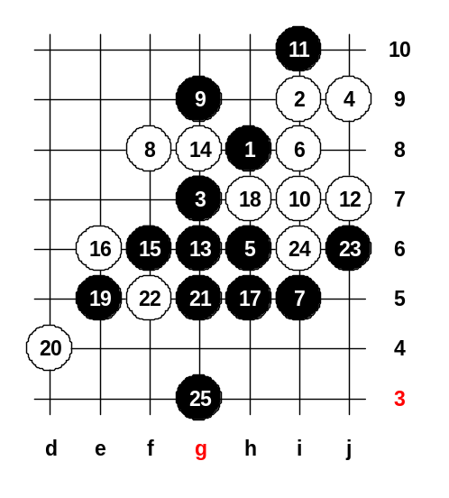

Apr 6 21:53
Hello! Welcome! Lets see the homework answer first. How many of you studied the last week homework? The position has been set up, please tell me the right steps now. Show me the black win please. KillerWen says g6, lets try it? He says 13-G6, 14-g8, 15-F6, 16any, 17-H5. 殺手文 is right!! Now black has VCF, so black won!

Apr 6 23:23
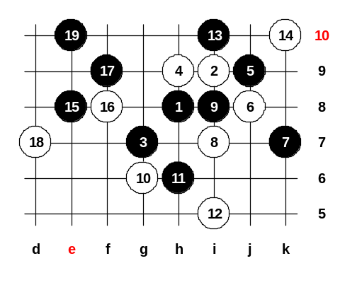
Now we will study the main 4th move in i11 opening. It is very important to know about 4-h9 because even in important tournaments sometimes players use that move. How about the 5th moves? Do you know? The 5-i7 is wrong move. If 5-i7 then 6-g9, 7-f9, 8-j8 and white wins. Both 5-f8 and 5-h6 lose after white's 6-i8. Please give me right 5th moves ^^ The strongest 5th move is j9. After 5-j9 black usually wins. There are two other 5th moves for black, too: 5-i8 and 5-g9. So, we have three choices: j9, i8, g9. When we put two 5th moves on the board in the game, one of them is usually j9, and the other is i8 or g9, as you wish. Lets study the 5-j9 first.
Wow, here are many 6th moves possible. Which one you would like to study? Ok, you want 6-j8. The black next move is k7. Somebody asked about 7-i7. It is a bad move because white can attack and win: 8-k7, 9-L6, 10-g9. And somebody wants to know about 7-i8. If 7-i8 then it will turn into the variant of 5-i8, which is not as good for black as 5-j9. So, with 7-i8 black loses his advantage. Let’s continue. The next white move after standard 7-k7 is 8-i7. In old times, there were many Japanese games played in this style. After long, the black win has been proved, so nearly all advanced players have stopped choosing this 5th move. In 1980, in the legendary match between Yoshizawa and Nakamura, Nakamura chose 9-i10 and won. Nakamura played very powerfully as black after 9-i10, so he won for sure. However, the theory says 9-i8 since this has been analyzed very deeply by many top players.
Let’s take a look at the best white move here:
The 12-i5, must! And now comes the beautiful connection move: 13-i10. These 13th moves have been invented by Japanese more than 20 years ago. However, the Japanese did not study all variants until the end, so they didn't know how to continue the attack. This is the reason why Japanese books few say about this pattern. In 1989-1992, in Russia, many players gambled in this variant hoping that black will fail the attack. Many players tried to search for the sure win here. Finally, by 1992 the black sure win had been found by European players. There are 3 choices for white now. The choices are h11, k10, k8.
If 14-h11 then 15-L8, 16-L7, 17-k10, and you will recognize the renju problem from the Inside Renju magazine's January issue. So, we will study 14-k10 and 14-k8. First k10. In 1992, European players made lots of analyses about 15-e8 and proved black win here. In case of other 15th moves, the black attack will fail. If 16-e9 or 16-f8 then 17-f9. Lets try 16-f8 first, I will show you the black attacking idea. Now, if white will protect upper side (18-g10) then black attacks below (19-e7). Therefore, white must play 18-d7. Can you guess the 19th move? ^^ Right, 19-e10. And now black win is quite simple, so I want to close this board and continue with other white defense moves which are more difficult.

Apr 6 23:29
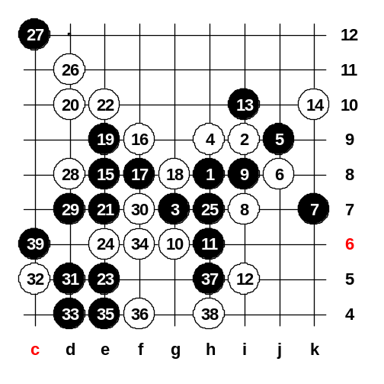
Now we will study the white's strongest defense 16-f9. Black will use straight attack. White has two choices to block a three in 22nd move. We play e10 first. White has only one choice: 26-d11 and 28-d8. The 35th move is very beautiful. This game was played in 1996 in Japan between Kawamura and Sagara. That proves, even though European knew the sure win already in 1992, the Japanese were not sure about it even 4 years later. After 39th move game is over, black has VCF no matter where white stops. Do you have any question about it? If no, then I will give you homework. We will study 14-k8 next week.

Apr 6 23:18
Homework: Please find the black win here and post your answer to board's message.
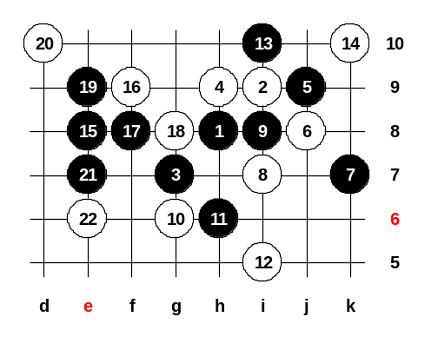
Class is over, thank you all for joining! ^__^

素早!? : Apr 7 22:59
23-k8, 24-L7, 25-D6, 26-C5, 27-E10, 28-E11, 29-C8 (好像有點牽強......^^)

奕學 : Apr 11 21:56
23-d6
(A)24-c5:
25-d8(B vcf g9, e11, f10)
1.26-h7(3), 27-h11, 29-c7.
2.26-e10, 27-h7(43 threat), 28-d7.Black vcf. h4, f6, e5, b8
3.26-c7, 27-h11, 28-any. Black vcf. g9, e11, f10, g11
(B)24-g9! 25-d7, 26-c7 is stronger.
27-d5, 28-d4, 29-b5, 30-c5, 31-b7 double threat.

素早!? : Apr 16 16:41
唉...我還是不行〉〈
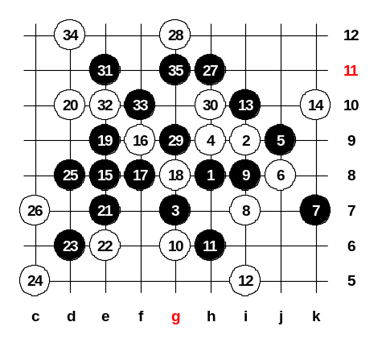

Apr 13 21:51
Let’s begin, we will study the homework answer first. How many of you know the black win here? Somebody says d8. If 23-d8 then 24-e10 and 26-d6 and black has no win. There is only one way to play: 23-d6, other ways cannot give win.

Apr 13 22:34
Now we will take a quick look at another 14th move. Anyone of you knows the right move from the book? Yes, 15-g11 is important move. It has two meanings. One meaning is defensive, the point g11 would be very useful for white, so black took it first. Another meaning is connective, black tries to connect k10 power with the left side. The third thing, that player has to keep in mind while doing such move: make sure white cannot play active, such as 16-h5. In this case, even 15-g11 does not make any attack lines, black can continue attacking if white goes h5. The idea is simple, connect both sides to create VCF threat. If 16-h5 then 17-k10, 19-g10 and black will have VCF threat. So, white must play in upper side defensively in 16th move.
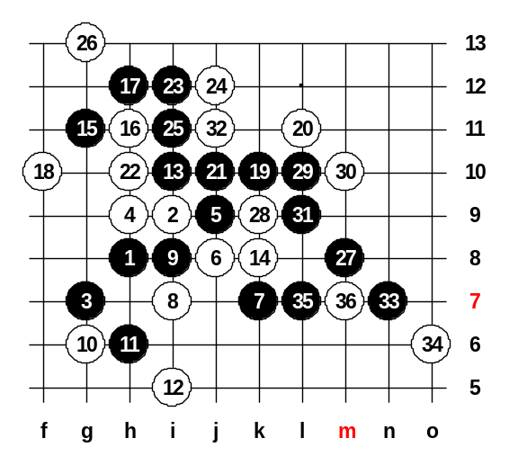
There are 3 strongest 16th moves: e9, f10 or h11.
If 16-e9 or 16-f10 then 17-h11. If 16-h11 then 17-h12. We don't have much time, so lets take a close look at one of them according to your choice. Which 16th move do you want to study? OK, h11 then. The 17-h12. What is the next? The 18-f10 is better than 18-e9 because after 18-e9 black will get too easy attack in upper side. Anyway, even if 18-f10, black still wins in upper side. Must 22-h10, otherwise black VCF. I think, both 23-i12 and 23-j12 are win moves. The 27-m8 win, I like this style. ^^ If 28-L10 then k9, L9, m7. Both 28-k9 and 28-m7 lose too. I can see I was careless and missed defense block at 6-line. So pity black cannot win in the beautiful style as I wished. So black must use simple style, 23-j12. Lets not move back, we can save this diagram as it is. Lets open new board.
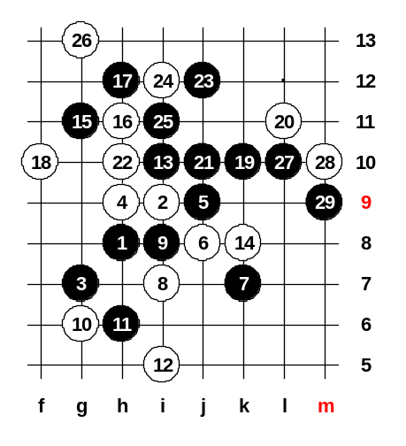

Apr 13 22:45
OK, position has been set up. Can anyone suggest any 24th move here? Black wins very easily. ^^ No need to move back because if any other defense move, then black win is same easy. Do you have any questions? If no question, then please let’s look at the new board and change the 10th move there. If 18-i13 then 19-e9, win.

